Chapter 3

Data Link Layer

**Design issues with data link layer are :**

1. **Services provided to the network layer –**   
   The data link layer act as a service interface to the [network layer](https://www.geeksforgeeks.org/design-issues-in-network-layer/). The principle service is transferring data from network layer on sending machine to the network layer on destination machine. This transfer also takes place via DLL (Dynamic Link Library).
2. [**Frame synchronization**](https://www.geeksforgeeks.org/framing-in-data-link-layer/)**–**   
   The source machine sends data in the form of blocks called frames to the destination machine. The starting and ending of each frame should be identified so that the frame can be recognized by the destination machine.
3. **Flow control –**   
   Flow control is done to prevent the flow of data frame at the receiver end. The source machine must not send data frames at a rate faster than the capacity of destination machine to accept them.
4. **Error control –**   
   Error control is done to prevent duplication of frames. The errors introduced during transmission from source to destination machines must be detected and corrected at the destination machine.

Framing

* Framing is a function of the data link layer.
* The bits to be transmitted is first broken into discrete frame at the data link layer.
* In order to guarantee that the bit stream is error free, the checksum of each frame is computed.
* When frame is received, it recomputed the checksum. If it is different then the data link layer knows that an error has occurred.
* Breaking the bits into frames is called as framing

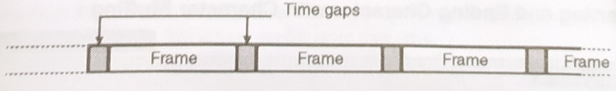

Framing Methods

* Character count
* Starting and ending characters, with character stuffing
* Character stuffing.
* Starting and ending flags, with bit stuffing
* Physical layer coding violations

Char Count

* In this method, a field in the header is used to specify the number of characters in the frame.
* This number helps the receiver to know the exact no. of characters present in the frame.
* The disadvantage of this method is that, an error can change the character count itself.

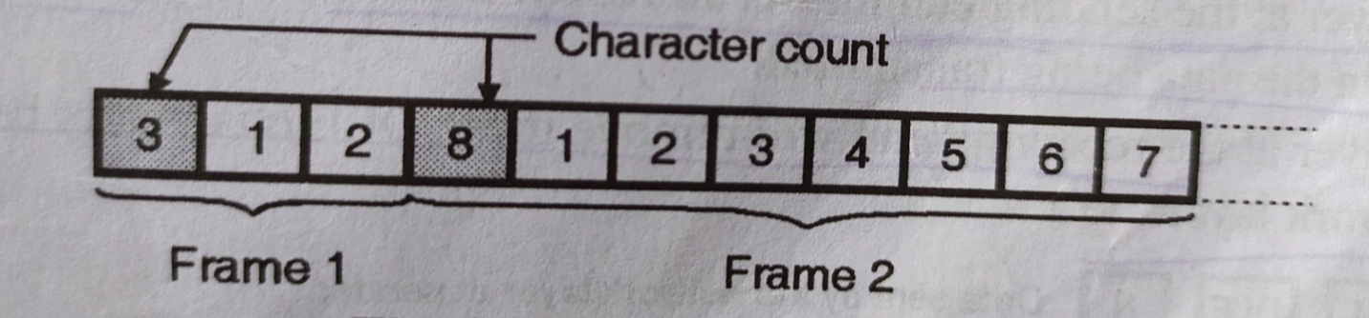

Starting and ending character with character stuffing

* The problem of character count method is solved here by using starting character before the starting of each frame and ending character at the end of each.
* STX DLE: Start of Text Data link escape.
* DLE ETX: Data link escape End of Text

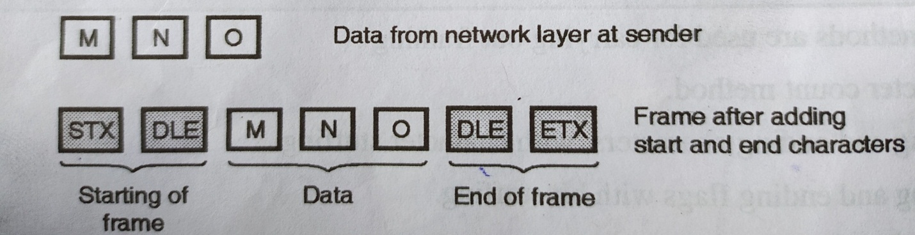

Character stuffing

* The problem with the earlier system is that the Character STX DLE or DLE EXT can be part of data as well.
* So at the sending end inserted DLE character just before each accidental DLE character in the data being transmitted.

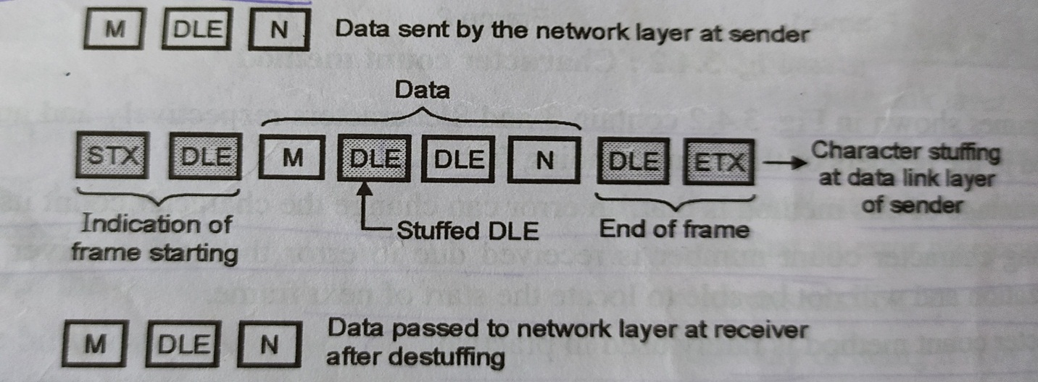

Byte stuffing

* In the Byte stuffing flag is added to the data section that is starting and ending of frame.
* Also the ESC character will allow the presence of the flag is the data section of a frame.

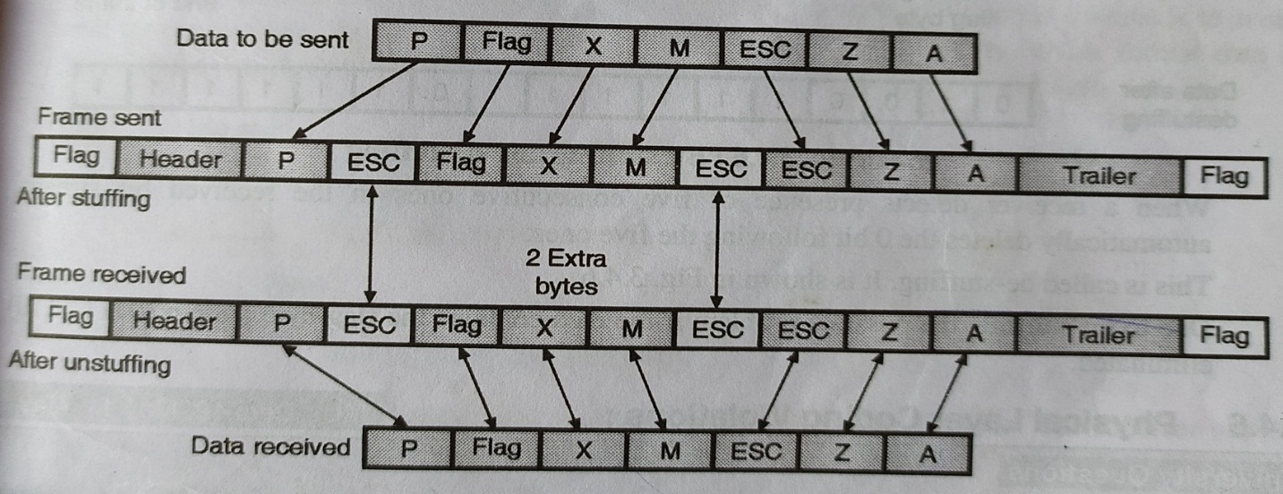

Starting and ending flag with bit stuffing

* In this method at the beginning and end of each frame 01111110 is added.
* Whenever sender data link layer detects the presence of 5 consecutive 1’s in data stream, it automatically stuff a o bit in ongoing stream.

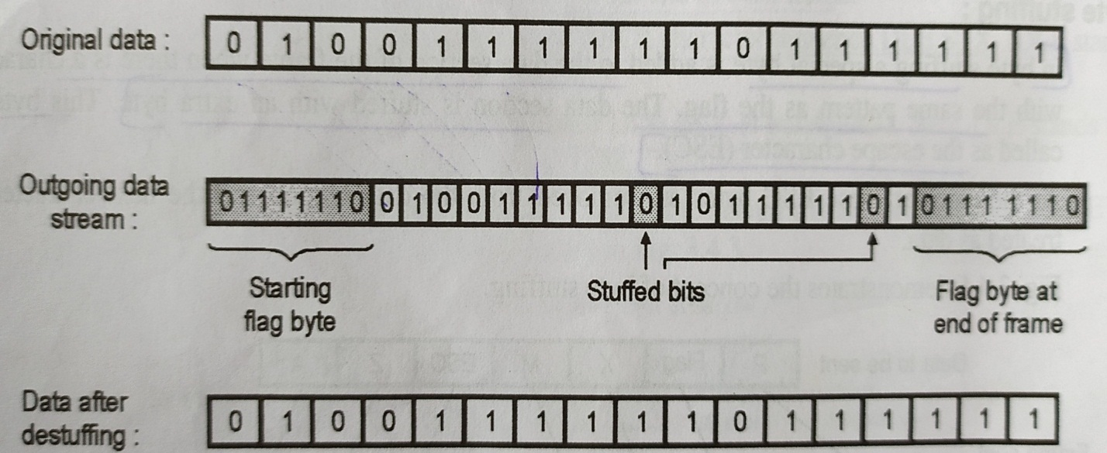

Physical layer coding violations

* The final framing method is physical layer coding violations and is applicable to networks in which the encoding on the physical medium contains some redundancy.
* In such cases normally, a 1 bit is a high-low pair and a 0 bit is a low-high pair.

